SCO FRIENDLY WEBSITE

### A MINI PROJECT REPORT

#### Submitted by

#### Group/Team No: G26/PG-21

**VANSHITA, 2310992318 [TEAM LEADER]**

**VARUN SAINI, 2310992319**

**VEER VANSHAJ WADEHRA, 2310992320**

#### in partial fulfillment for the award of the degree of

## BACHELEOR OF ENGINEERING

***in***

COMPUTER SCIENCE & ENGINEERING



**CHITKARA UNIVERSITY CHANDIGARH-PATIALA NATIONAL HIGHWAY**

**RAJPURA (PATIALA) PUNJAB-140401 (INDIA)** NOV-23

###### TABLE OF CONTENTS

|  |  |  |
| --- | --- | --- |
| **Sr.no** | **Section** | **Page no** |
| **1.** | Introduction | 1 |
| **2.** | Problem Statement | 2-3 |
| **3.** | Technical Details | 4-5 |
| **4.** | Key Features | 6-7 |
| **5.** | Project Advantages | 8-9 |
| **6.** | Results | 10-13 |
| **7.** | Conclusion with Future Scope | 14-15 |

**1.INTRODUCTION**

[Filterable Image Gallery](https://www.foolishdeveloper.com/) is a popular web element that is used around various websites.

It is a kind of image gallery where a large number of images are neatly arranged together. The notable point is that all the images can be sorted by category here.

There is a [navigation bar](https://www.foolishdeveloper.com/2021/08/responsive-navigation-menu-bar.html) where all the categories are sorted. When clicking on any one of those categories. Then all the images in that category are seen and the rest of the images are hidden. As a result, the user can easily find the images of his choice. This type of design is mainly used in many websites where a lot of images are put together.

However, in this case We have created this Filterable Image Gallery using HTML and CSS and Java script.

**2. PROBLEM STATEMENT**

The problem that the project aims to solve is the efficient organization and retrieval of images. Without filters, users may struggle to quickly find specific images in large collection. Filters provide a solution by allowing users to narrow down their image searches based on criteria such as tags, content or other data, making it easier to locate and view the desired images.

**SOME RELEVANT BACKGROUND INFORMATION AND RESEARCH**

**USER NEEDS:** What type of images the user want? What filtering options are most important to them

**EXISITING SOLUTIONS:** Researched existing image gallery websites

to analyse their features, strengths, weaknesses for improvement in our project.

**FILTERING ALGORITHMS:** Exploring different filtering algorithms such **as** coloured-based filters,

Content analysis, to determine which are more suitable for our project.

**USER INTERFACE DESIGN:** For considering usability and accessibility to create a user-friendly gallery with filter options.

**3. TECHNICAL DETAILS**

1. **HTML {HYPERTEXT MARKUP LANGUAGE}:**

**Use to structure the web page, including elements for headers, image containers and filters.**

1. **CSS {CASCADING STYLE SHEETS}:**

**For styling and formatting the web page, making it appealing and user friendly.**

1. **IMAGE CONTAINERS:**

**Creating HTML elements (e.g. <div>) to serve as image containers where we display images.**

1. **GRID LAYOUT:**

**Utilizing flexbox for arranging your image containers in a desired layout.**

1. **STYLING:**

**Applying CSS styles to control the appearance of gallery elements such as borders,**

**margins, padding and fonts.**

**4. KEY FEATURES**

1. **Clear Navigation and User-Friendly Design**:
   * Intuitive menus and organized content.
   * Easy access to essential sections (e.g., articles, resources, services).
2. **Responsive and Accessible Design**:
   * Ensure the website works well on various devices (desktop, tablet, mobile).
   * Prioritize accessibility for users with disabilities (screen readers, keyboard navigation).
3. **Educational Content**:
   * Articles, blog posts, and infographics on physical health (nutrition, exercise, sleep) and mental health (stress management, coping strategies).
   * Reliable sources and evidence-based information.
4. **Interactive Tools and Assessments**:
   * Self-assessment quizzes (e.g., mental health check, stress levels).
   * Calorie calculators, fitness trackers, or sleep trackers.

**5. Project Advantages**

**FUNCTIONALITY:**

Our project works to ease the usage of a complicated gallery in such a way that whichever type of pictures you want to browse you just need a single click on the name tag of that type such as CATS, WALLPAPERS, CARS etc.

**DESIGN/STYLING:**

With the help of CSS we have tried making an user-friendly and an attractive filterable image gallery. Which is an eye-catching and playful project with different styles.

**CODE REVIEW:**

With the help of HTML and INLINE CSS we have completed this project using many different tags such as <header>, <h1>, <img>, <div> etc.

And have completed the styling with the help of inline CSS by using <style> tag, background-color, font-family, font-size etc inside the <style> tag.

**6. Results**

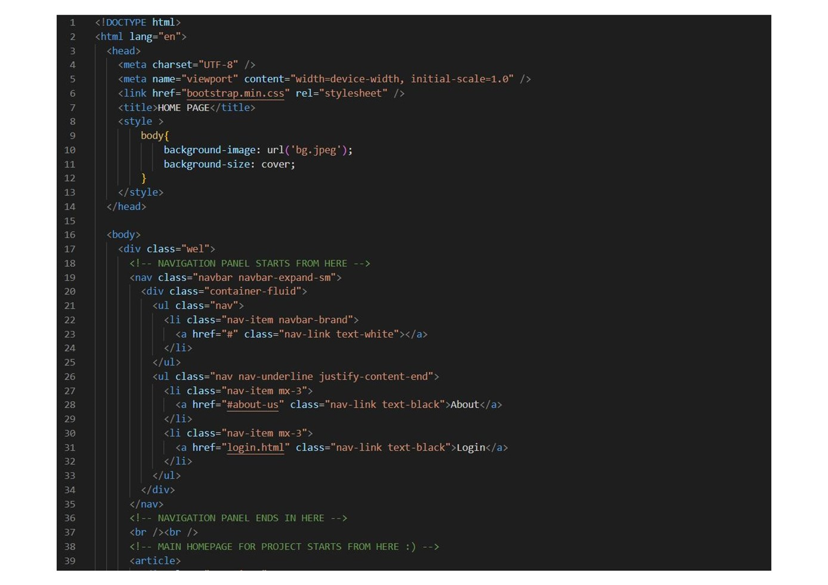

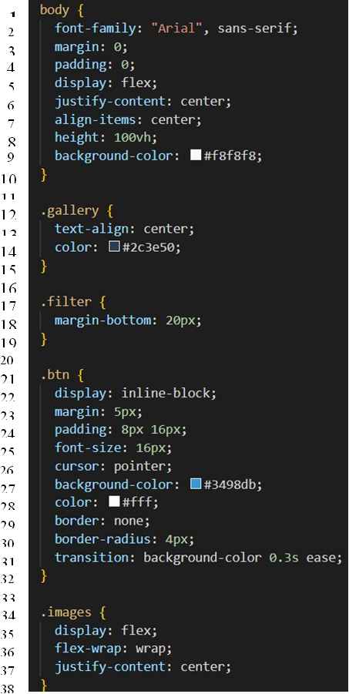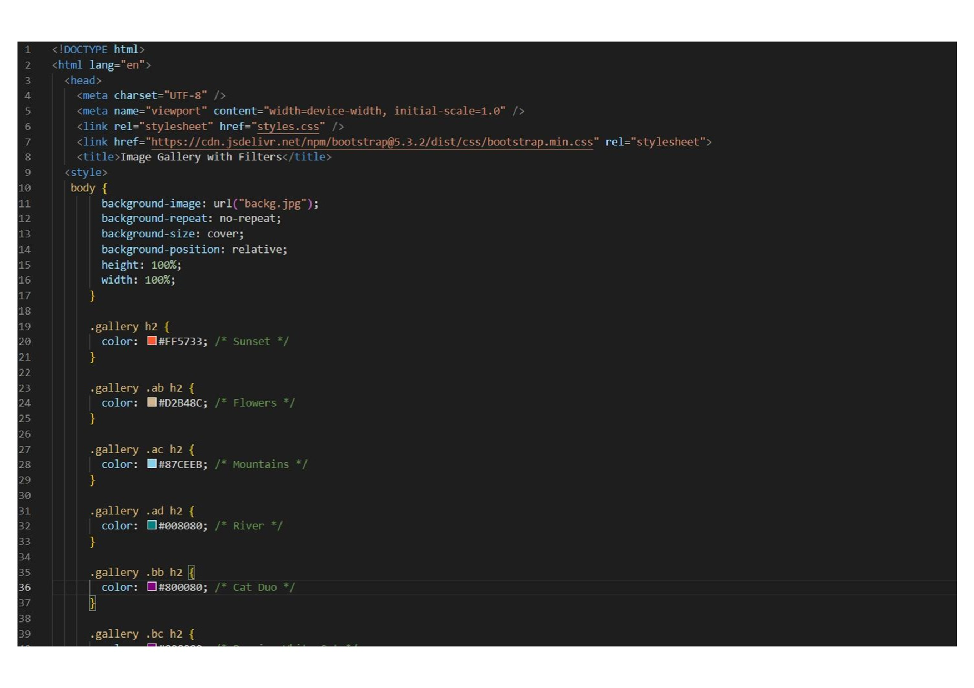

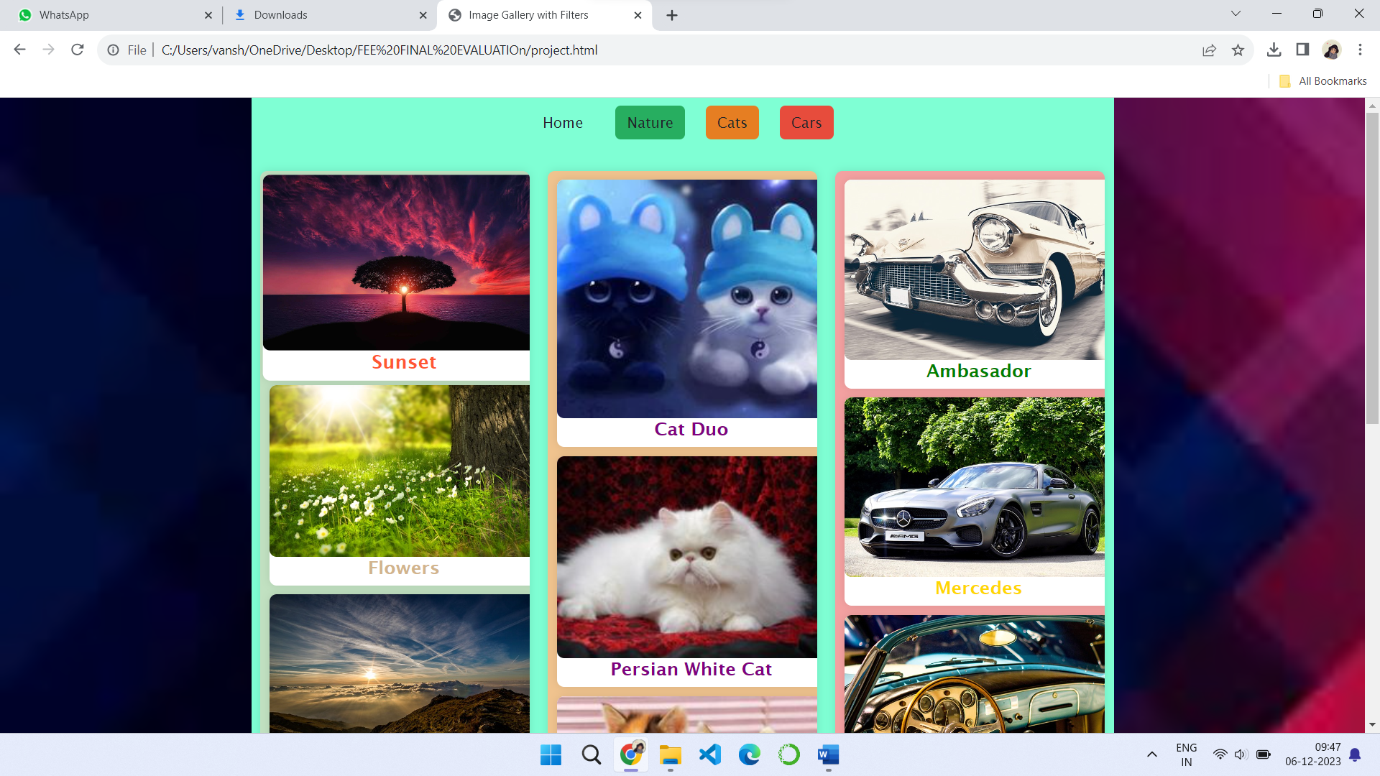



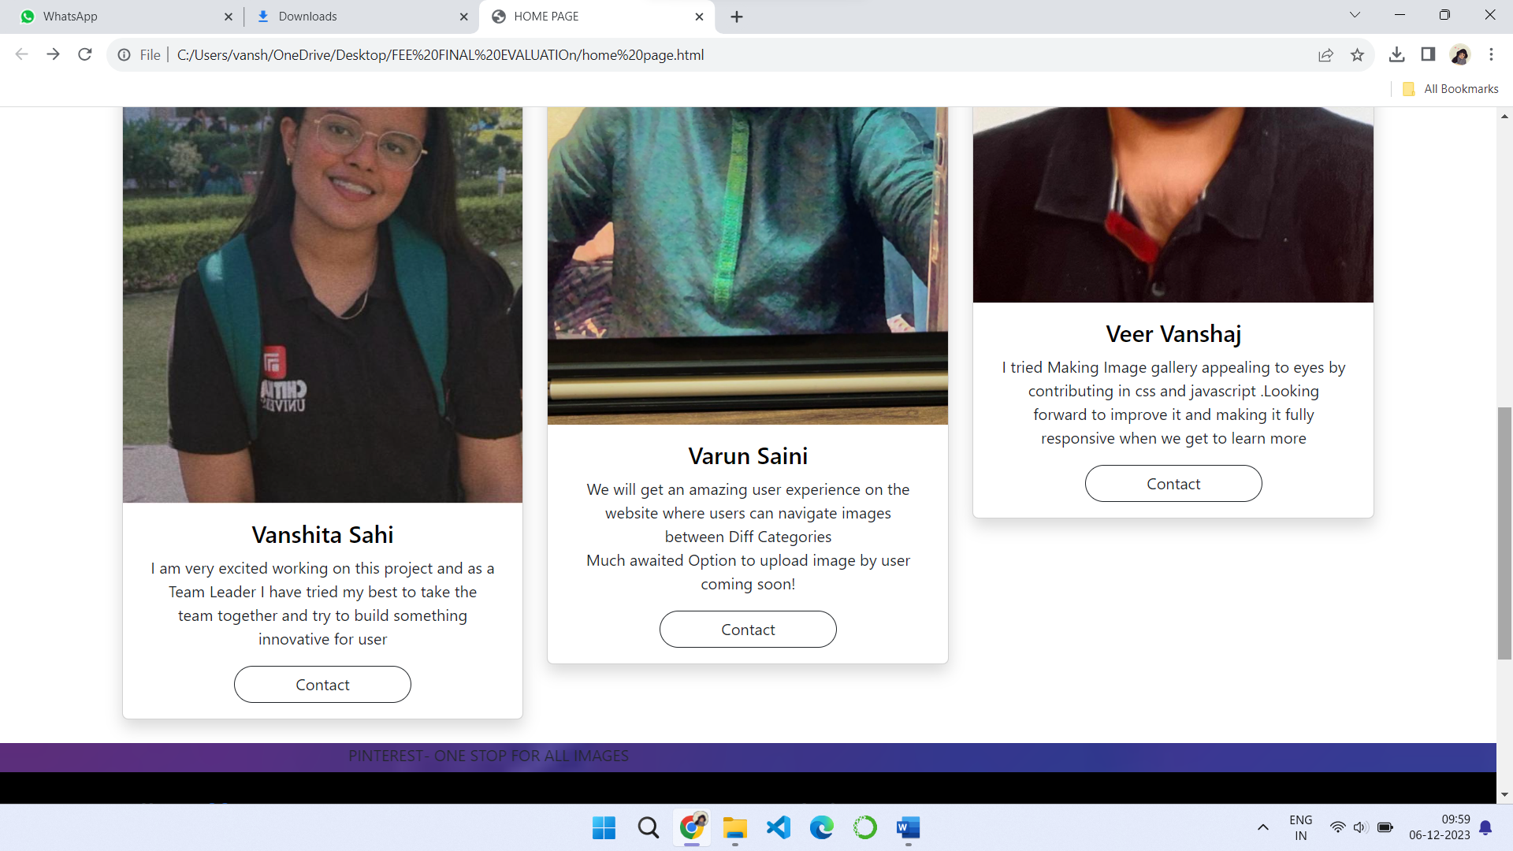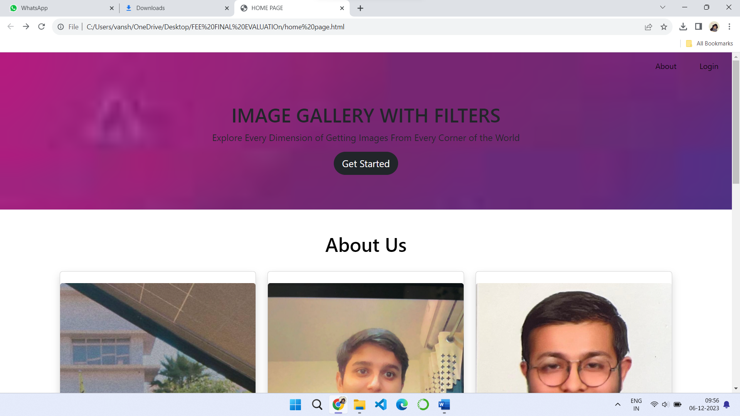

**7. CONCLUSION WITH FUTURE SCOPE**

**A user-friendly and an attractive gallery is formed by 3 of us to help and make it an easy way for people to go through an image gallery with n number of photos by just clicking on the type of picture you want to see and getting that instantly rather than scrolling through the whole page for**

**finding that.**

**Creating an image gallery with filters using HTML and CSS is a great project, and its future scope can involve several enhancements and features. Here are some ideas:**

**Responsive Design: Ensure your gallery looks good on various devices and screen sizes.**

**Lazy Loading: Implement lazy loading to improve performance, especially if dealing with a large number of images.**

**Image Modal: Allow users to click on images for a larger view within a modal.**

**Dynamic Content: Connect your gallery to a database or external API to dynamically fetch and display images.**

**Sorting Options: Provide options for sorting images based on different criteria such as date, popularity, or category.**

**Search Functionality: Add a search bar to allow users to quickly find specific images.**

**Social Media Integration: Include social media sharing buttons or integration for users to share their favorite images.**